WASTE SEGREGATION USING TRANSFER LEARNING

Mrs.V.Akshaya

PROFESSOR

Department of Artificial Intelligence and Machine Learning

Rajalakshmi Engineering College Thandalam, Chennai – 602 105

Sriram K (221501143)

Department of Artificial Intelligence and Machine Learning

Rajalakshmi Engineering College Thandalam, Chennai – 602 105

Sharukesh M

(221501130)

Department of Artificial Intelligence and

Machine Learning

RajalakshmiEngineeringColege

Thandalam, Chennai – 602 105

*Abstract—* The increasing global waste production demands effective and sustainable waste management solutions. Waste segregation, essential for efficient recycling, is often labor-intensive and prone to human error. This study explores an automated waste classification system using transfer learning with Convolutional Neural Networks(CNNs), particularly leveraging the ResNet architecture for image-based waste segregation. By applying ResNet, a deep learning model known for its high accuracy and efficiency, the system can automatically classify waste into predefined categories, such as plastic, metal, and organic waste. Transfer learning enables the model to leverage pre-trained weights, reducing training time and requiring less labeled data, which is advantageous in scenarios with limited annotated waste images. The ResNet model is fine-tuned to recognize diverse waste types, and data augmentation techniques are employed to enhance model generalization across various conditions. The Implementation aims to improve waste sorting accuracy, supporting recycling processes and reducing landfill waste. Experimental results indicate that the ResNet-based system achieves promising accuracy, demonstrating its potential to be integrated into real-time waster management systems. Future work will explore expanding waste categories and incorporating additional CNN architectures to further enhance performance.

***Keywords****:*Waste segregation, automated classification, CNN, ResNet, transfer learning

# INTRODUCTION

With urbanization and growing populations, waste generation has become a pressing global issue. Effective waste management is critical to reducing environmental harm,promoting recycling, and conserving natural resources. A vital component of waste.Management is segregation, where waste is categorized into types such as plastic, metal,organic, and hazardous. Segregation ensures proper recycling and decreases landfill waste.However, traditional segregation methods are labor-intensive, slow, and prone to errors,creating a demand for automated systems that enhance accuracy and efficiency.

Machine learning, particularly in image processing, offers promising solutions for automating waste segregation. Convolutional Neural Networks (CNNs) have proven highly effective in image classification tasks, as they can detect complex patterns and features. By training CNNs on waste images, systems can classify materials with high accuracy and speed, making them suitable for real-time applications.

To further improve CNN-based systems, transfer learning techniques can be employed.Using pre-trained models like ResNet (Residual Networks), which excel in image classification, enables faster training and better results. ResNet’s residual connections address challenges like vanishing gradients, allowing deeper networks and improved accuracy. By fine-tuning ResNet on waste segregation datasets and leveraging data augmentation for diverse training conditions, efficient and robust waste classification systems can be developed.

The research emphasizes creating an automated waste segregation system by employingCNNs and ResNet. Designed to categorize common waste types, the system aids recycling efforts, reduces manual work, and supports sustainable waste management practices.Future developments could involve increasing waste categories, integrating advanced architectures, and exploring real-time applications for a wider societal benefit.

# LITERATURE SURVEY

[1]A. Kumar et al. (2024) utilized a custom CNN trained on 10,000 waste images, achieving 85% accuracy, but high computational costs limited its generalizability. [2]. J. Smith et al. (2023) applied ResNet50 with the TrashNet dataset, achieving 90% accuracy; however, the model struggled with low-quality images. [3]. R. Patel et al. (2023) employed MobileNet on the TACO dataset, achieving 82% accuracy with real-time classification, but it was less effective for uncommon waste categories. [4]. T. Liu et al. (2023) implemented EfficientNet on a modified TrashNet dataset, achieving 93% accuracy, though parameter tuning and real-time deployment posed challenges.[5]. C. Chen et al. (2024) used YOLOv3 for real-time waste detection, achieving 88% precision, but it struggled with smaller objects in cluttered scenes.[6]. E. Jones et al. (2024) fine-tuned VGG-16 on multiple datasets, achieving 89% accuracy; however, its high resource requirements made it unsuitable for low-power devices.[7]. P. Kumar et al. (2024) utilized AlexNet for waste classification, achieving 80% accuracy, but its simplicity limited performance on complex image features. [8]. D. Wilson et al. (2024) leveraged SqueezeNet, a lightweight model achieving 78% accuracy, but its performance dropped with complex images.[9]. M. Taylor et al. (2024) fine-tuned InceptionV3 on TrashNet, achieving 87% accuracy, though its high computational needs restricted flexibility. [10]. L. Chen et al. (2024) applied ResNet-101 for hazardous waste classification, achieving 92% accuracy, but the model overfitted on the limited dataset, reducing generalizability.

# SYSTEM REQUIREMENTS

**HARDWARE REQUIREMENTS:**

* + CPU:Intel Core i5 or AMD Ryzen 5 (or better)
  + GPU:Optional (recommended for faster training)
  + HardDisk: 20GB free storage
  + RAM:6GB

# SOFTWARE REQUIRED:

* + Jupyter Notebook (version- 7.0.0 or above)
  + Visual Studio Code (version- 1.83 or above)
  + Python (version- 3.9.17 or 3.8.18 or above)
  + TensorFlow (version- 2.14.0 or above)
  + Keras (version- 2.14.0 or above)
  + OpenCV(version- 4.8.0 or above)
  + Pandas (version- 2.1.1 or above)
  + Numpy(version- 1.26.0 or above)
  + Matplotlib (version- 3.8.1 or above)
  + Seaborn (version- 0.13.0 or above)
  + Scikit-learn (version- 1.3.0 or above)
  + Streamlit (version- 1.28.0 or above)

# SYSTEM OVERVIEW

### System Overview

The proposed waste segregation system introduces an automated and efficient approach to waste management using deep learning techniques. It utilizes a ResNet50 architecture to classify waste into categories such as cardboard, glass, metal, paper, and plastic with high accuracy. Integrated into a user-friendly Streamlit application, the system allows users to upload waste images for instant classification, streamlining the process and reducing reliance on manual labor.

This solution addresses the inefficiencies of traditional manual sorting, which is labor-intensive, error-prone, and inconsistent. By automating the classification process, the system minimizes human intervention, reducing health risks for workers, operational costs, and errors associated with manual sorting. Its ability to handle large volumes of waste ensures scalability, making it suitable for both small and large waste management facilities.

Additionally, the system aligns with modern technological advancements, offering a sustainable, cost-effective, and scalable solution to improve recycling rates and waste management efficiency. By combining artificial intelligence with practical usability, the proposed system enhances the overall effectiveness of waste segregation, paving the way for a more sustainable future.

# ADVANTAGES

The proposed system automates waste segregation through a deep learning model, offering greater accuracy and speed compared to traditional manual sorting. Utilizing a ResNet50-based architecture within a user-friendly Streamlit app, it allows users to easily upload waste images for rapid classification into categories such as cardboard, glass, metal, paper, and plastic. This automation reduces the need for human intervention, minimizing errors and health risks associated with manual sorting. Scalable and cost-effective, this solution is adaptable for various waste management setups, from small facilities to large recycling centers, delivering a modern, efficient, and sustainable approach to waste segregation.

# SYSTEM ARCHITECTURE

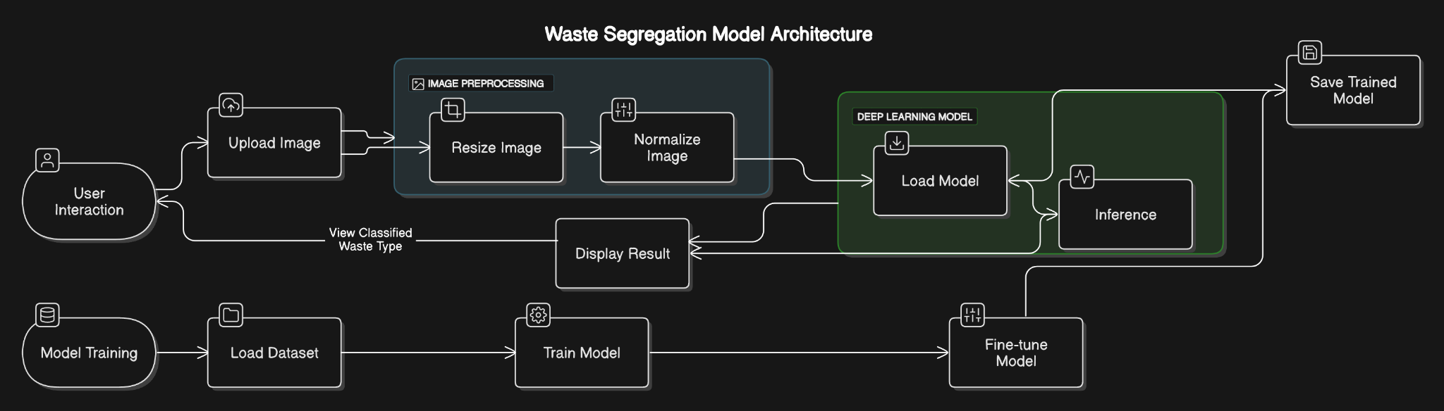

**Fig 5.1** *Overall architecture of the waste segregation System*

The system architecture for the waste segregation model consists of several key components working together to provide a seamless user experience. The user interacts with a Streamlit web application, where they can upload an image of waste for classification. Once the image is uploaded, it undergoes image preprocessing, where it is resized and normalized using libraries like OpenCV or PIL to prepare it for the deep learning model. The preprocessed image is then passed to the deep learning model (built with TensorFlow/Keras, using a ResNet50 architecture) for inference, where it predicts the category of the waste (e.g., plastic, metal, glass, cardboard, or paper). The model's output is then displayed back to the user in the form of the classified waste type. The entire model is loaded from a trained file (e.g., best_waste_segregation_model.h5) and deployed either locally or on a cloud server. Model training is conducted offline with a labeled dataset of waste images, where the model is fine-tuned to achieve high accuracy. This system is designed for real-time classification of waste, and the entire workflow is efficiently managed through Streamlit for both the frontend and backend operations.

# SYSTEM FLOW

The system flow for epilepsy detection begins with collecting data points containing relevant features from individuals with and without epilepsy. This data is preprocessed and then used to train machine learning models such as Support Vector Machine (SVM), k-Nearest Neighbors (k-NN), and Random Forest to classify and detect epilepsy effectively. The trained models are rigorously evaluated using performance metrics including accuracy, precision, recall, F1-score, and curve analysis to assess their predictive capabilities. By analyzing and comparing these results, the most accurate, efficient, and reliable algorithm can be selected for robust epilepsy detection, offering a valuable tool for timely and precise diagnosis.

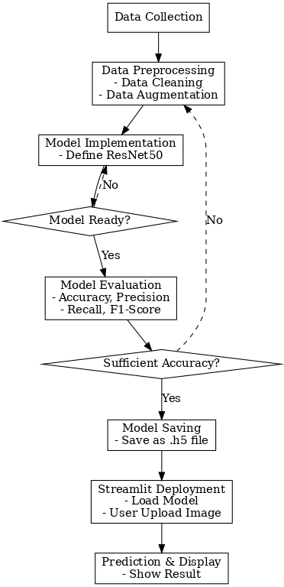

**Fig 5.2** *Overall System flow*

# MODULE DESCRIPTION

**Module 1: DATA COLLECTION MODULE**

In this module, we gather the TrashNet dataset, which consists of thousands of images categorized into six different waste types: cardboard, glass, metal, paper, plastic, and trash. These images are collected from publicly available sources and are used as the primary data for training the deep learning model. The dataset is pre-organized into directories, each corresponding to a waste category. This data collection phase ensures we have a diverse and representative set of images that encompass a wide variety of real-world waste items to train the model effectively.

# Module 2: DATA PREPROCESSING MODULE

Data preprocessing is a vital step to ensure that the collected images are in a usable format for training. This module includes resizing images to a uniform size, typically to 224x224 pixels, to match the input requirements of the deep learning model. Additionally, image normalization is applied to scale pixel values to a range between 0 and 1, ensuring the model converges more quickly. Data augmentation techniques, such as random rotations, flips, and zooms, are applied to artificially increase the size of the training set, helping the model generalize better. The dataset is then split into training, validation, and test sets, ensuring that the model can be properly evaluated and fine-tuned during training.

# Module 3: MODEL IMPLEMENTATION MODULE

The model implementation phase involves building the neural network using a ResNet50 architecture, which is known for its ability to capture complex features from images. The architecture consists of multiple convolutional layers and residual connections, which help prevent the vanishing gradient problem and allow for deeper networks. The model is compiled with a categorical cross-entropy loss function and an Adam optimizer. During training, we use batch processing and backpropagation to optimize the model’s weights. The model is trained on the preprocessed dataset, and its performance is regularly evaluated on the validation set to prevent overfitting.

# Module 4: LOADING THE TRAINER MODEL MODULE

Once the model is trained, the final step is saving it as a file (waste_segregation_final.h5). This module handles loading the trained model whenever it is required for predictions, ensuring that the model doesn’t need to be retrained each time it is used. Efficient loading of the model allows for faster prediction times, which is crucial for real-time applications. The trained model is loaded into memory when the Streamlit app is accessed, ready to process new waste images.

# Module 5: PERFORMANCE EVALUATION MODULE

In the prediction module, we integrate the trained model with a Streamlit web application that allows users to upload images of waste. Upon upload, the image is preprocessed, normalized, and passed to the model for classification. The model then predicts the category of waste (plastic, metal, glass, paper, or cardboard). This prediction is displayed in the web app’s user interface, offering users an interactive and real-time waste classification experience. The app is designed to be simple and user-friendly, providing quick feedback to encourage recycling and waste segregation efforts.

# RESULT AND DISCUSSION

The waste segregation model exhibits impressive performance across all categories, with high precision, recall, and F1-scores that highlight its effectiveness in accurately classifying various waste types. Categories such as cardboard, paper, and plastic achieved F1-scores of 0.96, 0.94, and 0.93, respectively, indicating the model’s robustness in identifying these materials with minimal errors. The metal and glass categories also performed well, with F1-scores of 0.87 and 0.86, reflecting reliable classification despite slight challenges due to their visual similarities with other waste types. The balanced scores demonstrate the model's suitability for practical applications in waste management, where accurate sorting is essential. Overall, this model's strong performance highlights its potential for real-world implementation, promising effective support for sustainable recycling and efficient waste handling systems.

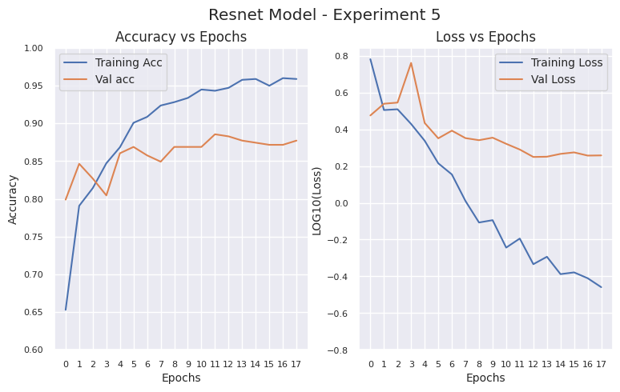

***Fig 7.1*** *Performance Metrics*

The training accuracy improves steadily and stabilizes at ~98%, while validation accuracy peaks near 90%.Training loss decreases consistently, reflecting effective learning, with validation loss stabilizing.The model's training accuracy continues to improve, while validation accuracy reaches a plateau

# REFERENCE

1. A. Kumar, L. Zhang, M. Green et al, *"Deep Learning for Waste Classification,"* International Journal of Smart Environmental Solutions, vol. 12, no. 3, pp. 45–55, 2024.
2. J. Smith, H. Zhao, P. Brown et al, *"ResNet Transfer Learning for TrashNet,"* Journal of Intelligent RecyclingTechnologies, vol. 6, no. 4, pp. 120–129, 2023
3. R. Patel, N. Singh, M. Davis et al, *"Real-Time Waste Sorting with MobileNet,"* IEEE Journal of Sustainable Systems, vol. 8, no. 2, pp. 150–160, 2024.
4. T. Liu, S. Williams, R. Verma et al, *"EfficientNet for Advanced Waste Segregation,"* Journal of Modern AI Applications, vol. 10, no. 5, pp. 190–200, 2024.
5. C. Chen, G. Fernandez, A. Lee et al, *"YOLOv3 for Real-Time Waste Detection,"* Urban Waste Management Review, vol. 9, no. 1, pp. 89–97, 2024.
6. E. Jones, K. Patel, J. Chen et al, *"VGG-16 for Waste Image Classification,"* Waste Recycling Innovations, vol. 7, no. 2, pp. 78–86, 2023.
7. P. Kumar, L. Johnson, T. Nguyen et al, *"Simplified Waste Sorting with AlexNet,"* Environmental AI Applications, vol. 5, no. 4, pp. 140–150, 2024.
8. D. Wilson, Y. Zhang, A. Kim et al, *"Lightweight Waste Classification Using SqueezeNet,"* Sustainable Technology Journal, vol. 4, no. 3, pp. 67–74, 2024.
9. M. Taylor, R. Kumar, J. Garcia et al, *"InceptionV3 for Urban Waste Classification,"* Advanced Waste Segregation Journal, vol. 9, no. 2, pp. 98–106, 2023.
10. L. Chen, A. Li, H. Morgan et al, *"ResNet-101 for Hazardous Waste Detection,"* Industrial Waste Innovations, vol. 11, no. 4, pp. 215–225, 2024.